Circuit Analysis (Lab # 6)
Experiment 6: VERIFICATION OF KIRCHHOFFS LAWS

Name: ABEERA ASHFAQ Registration no : 2025-CE-66

Date: 25-4 26 Grade and Signature: ………………………

CLO2  CLO3 | Use with identification the circuit components, breadboards, multimeters, power supplies, signal generators, and oscilloscopes.  Make measurements in their own constructed electric circuits.
Psychomotor/Affective | Level1 (1) | Level2 (2-3) | Level3 (4-5) | Level4 (6-7)
Report Marks (3) |  |  | Total marks  (10)

Objective
To verify Kirchhoff’s current law and Kirchhoff’s voltage law for the given Circuit.
Apparatus Required
Sr. no | Apparatus | Range | Quantity
1 | Regulated Power Supply | Standard | 1
2 | Signal Generator | Standard | 1
3 | Oscilloscope | Standard | 1
4 | Digital Multimeter | Standard | 1
5 | Breadboard & Wires | Standard | As Required
6 | Resistors | 330ohm, 220ohm 1kohm | 3
Description
KCL: The algebraic sum of the currents meeting at a node is equal to zero.
KVL: In any closed path / mesh, the algebraic sum of all the voltages is zero.
Precautions:
- Voltage control knob should be kept at minimum position.
- Current control knob of RPS should be kept at maximum position.

Procedure for KCL:
- Give the connections as per the circuit diagram.
- Set a value in RPS.
- Note down the corresponding readings using multimeter
- Repeat the same for different voltages
Circuit - KCL

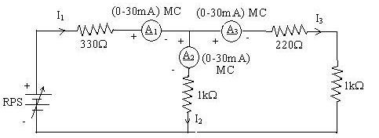

KCL - Practical Values:

Sl. No. | Voltage E |  | Current |  | I1 = I2 + I3
 |  | I1 | I2 | I3
 | Volts | mA | mA | mA | mA
1 | 5 | 5.6 | 3.12 | 2.56 | 5.68
2 | 15 | 17.05 | 9.37 | 7.68 | 17.05
3 | 25 | 28.42 | 15.62 | 12.80 | 28.42

Procedure for KVL:
- Give the connections as per the circuit diagram.
- Set a value in RPS.
- Note all the voltage reading
- Repeat the same for different voltages

Circuit - KVL

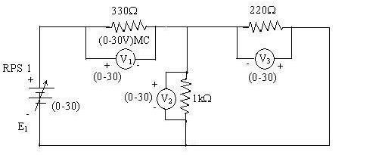

KVL - Practical Values

Sl. No. | RPS |  | Voltage |  | E1 = V1 + V2
 | E1 | V1 | V2 | V3
 | V | V | V | V | V
1 | 5 | 1. 7 | 3.23 | 0.71 | 5.00
2 | 10 | 2.13 | 6.45 | 1.42 | 10.00
3 | 15 | 3.19 | 9.68 | 2.13 | 15.00

Result:
Thus, Kirchhoff’s voltage law and Kirchhoff’s current law are verified practically by performing this experiment.

Post Lab Questions

- Define Kirchhoff’s current law.

Kirchhoff's Current Law states that the algebraic sum of all currents entering and leaving a node (junction) in an electrical circuit is equal to zero. In other words, the total current flowing into a node equals the total current flowing out of it. Mathematically: ΣI = 0 at any node, or equivalently, I_in = I_out. This law is based on the principle of conservation of electric charge — charge cannot accumulate at a node

- Define Kirchhoff’s voltage law.

Kirchhoff's Voltage Law states that the algebraic sum of all the voltages (EMFs and voltage drops) around any closed loop or mesh in a circuit is equal to zero. Mathematically: ΣV = 0 around any closed loop. This law is based on the principle of conservation of energy — the energy supplied by the source is completely consumed by the resistors in the loop. Voltage rises (sources) are taken as positive and voltage drops (across resistors) are taken as negative (or vice versa, consistently).
- What are the applications of regulated power supply?
A Regulated Power Supply has the following applications• It provides a constant, stable DC voltage to electronic circuits regardless of load variations or input voltage fluctuations.
Used in computers, televisions, mobile chargers, and other consumer electronics to supply steady voltage to sensitive components.
Used in industrial control systems, medical equipment, and communication devices where precise voltage is critical.
Used as a reference voltage source in measurement and instrumentation systems.

- What are the limitations of KCL?

KCL assumes lumped circuit elements and is not applicable to distributed parameter networks where the circuit dimensions are comparable to the wavelength of the operating frequency.
At very high frequencies (RF and microwave circuits), parasitic capacitances between conductors allow displacement currents to flow, violating the assumption that no charge accumulates at a node.
KCL is not directly applicable to non-linear circuits without proper modification.
It does not account for electromagnetic radiation — when currents change rapidly, radiation effects mean some current is "lost" as radiated energy.
KCL applies only to steady-state or slowly varying (quasi-static) conditions.

